**Vineet Mittal of Avaada Group at ADIPEC 2024: Calls for $200 Trillion Investment, Far Exceeding $35 Trillion Estimate for Energy Transition**

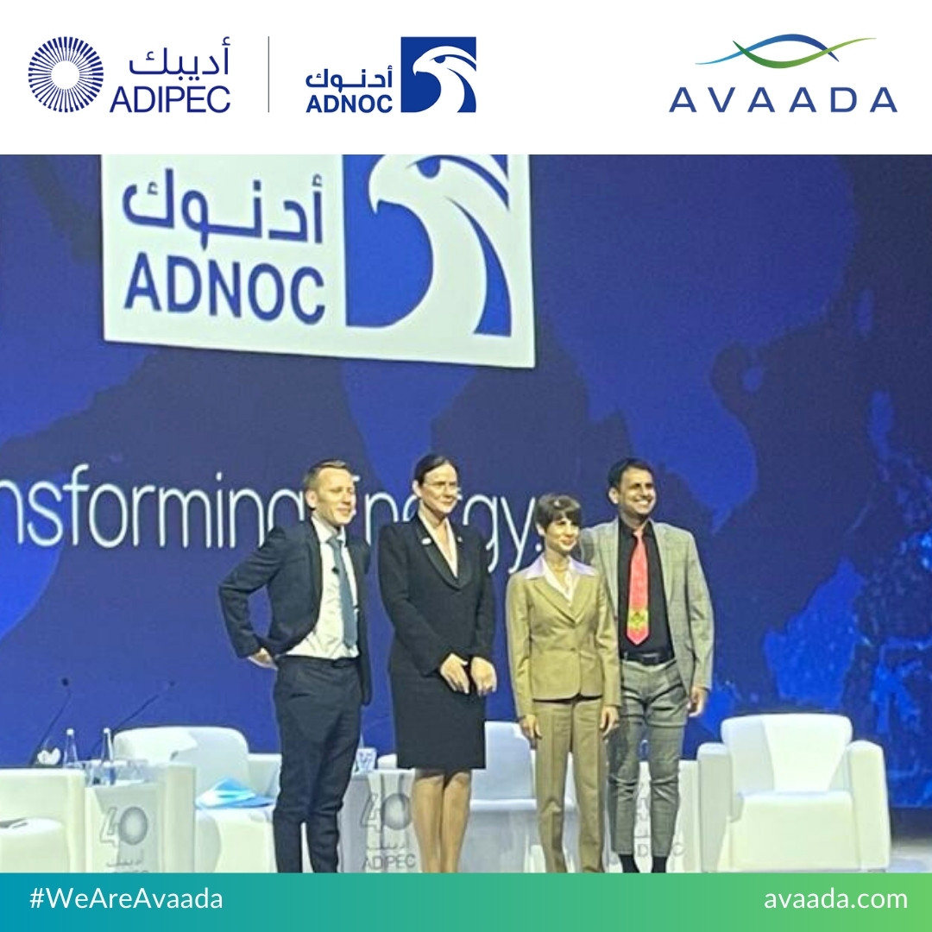

Abu Dhabi, 5th November, 2024 – Avaada Group, a leading renewable energy company from India, addressed attendees at ADIPEC 2024, the world's largest energy conference in Abu Dhabi, emphasizing the financial and regulatory commitments essential to driving the global energy transition.

During a critical debate at the summit, **Vineet Mittal, Chairman of Avaada Group**, highlighted the commonly cited $35 trillion estimate for transitioning the world to sustainable energy by 2050 to be highly conservative, stating that a more realistic target should be closer to $200 trillion.

In a sector-by-sector breakdown, there was a focus laid on the urgency of this investment to achieve a climate-secure future. With 2023’s energy investment hitting a record $2.8 trillion, Mittal explained that a continued investment at this level will fall far short. *“If we’re serious about meeting our 2050 goals, we need to double down on funding to reach around $6 trillion annually,”* he stated. *“This is the scale of investment required to build resilient, low-emission energy infrastructure on a global level.”*

**Key ADIPEC panel points included:**

* Power Sector Transformation: A 93% reduction in emissions is required by 2035, which will necessitate tripling global renewable energy capacity to 11 TW by 2030 and reaching 31 TW by 2050.
* Transportation Shift: By 2034, 100% of new passenger vehicles must be electric, with the entire passenger fleet electrified by 2046.
* Green Hydrogen’s Role: Clean hydrogen production needs to increase fourfold, from 94 million tons today to 400 million tons by 2050, to decarbonize energy-intensive sectors like industry and transportation.

The panel also discussed the critical need for **private sector involvement in green tech**. Mittal argued for policies that foster international cooperation and open-sourcing technologies, such as through the ***“One Sun, One World, One Grid”*** initiative, to optimize renewable energy use across regions. Avaada advocates for innovative financing methods—such as first-loss guarantees, fair public-private partnerships (PPP), and transparent carbon pricing—to make green projects more viable for private investors, particularly in the Global South.

**Green hydrogen remains a key element of Avaada’s strategy for a sustainable future.** Drawing on lessons from the solar industry’s scale-up, Mittal called for global policy incentives like feed-in tariffs to support green hydrogen’s growth. *“If we make green hydrogen affordable, we can decarbonize sectors that are otherwise difficult to transition, such as heavy industry, aviation, and shipping,”* he noted. Avaada is actively pursuing green hydrogen projects, leveraging its renewable expertise and collaborating with international partners to drive a competitive, scalable hydrogen market.

Vineet Mittal concluded with a call for collaboration between new clean-energy companies and established industry leaders, combining agility with financial scale to fast-track the energy transition. *“A sustainable future isn’t a single company’s achievement—it’s a global effort, demanding innovative partnerships and a unified commitment to transformation,”* he stated.

Avaada’s participation in ADIPEC 2024 emphasizes its leadership and commitment to advancing clean energy and offers a roadmap to achieve a sustainable, resilient energy future on a global scale.

**About Avaada Group:**

Avaada Group is at the forefront of the global energy transition, with expertise in solar module manufacturing, renewable power generation, and the development of green hydrogen, green methanol, green ammonia, and sustainable aviation fuel projects. Under the leadership of Mr. Vineet Mittal, Avaada has emerged as a major global energy player. Avaada Energy, its renewable power generation arm, aims to reach an installed capacity of 11 GWp by 2026. The group’s strong execution capabilities and proven track record have attracted significant international investments, including a US $1.3 billion funding commitment in early 2023, comprising US $1 billion from Brookfield’s Energy Transition Fund and $300 million from GPSC, a subsidiary of Thailand’s PTT Group.

**For further information, please contact:**

|  |  |
| --- | --- |
| Avaada Group  Corporate Communications  8850960705  corporatecommunications@avaada.com    Website: [www.avaada.com](http://www.avaada.com/)  Twitter: @avaadagroup  Facebook: @AvaadaGroup  LinkedIn: @AvaadaGroup | PR Contact:  Storytellers 101  Suraj Gupta  +918433649458  [suraj.gupta@storytellers101.com](mailto:suraj.gupta@storytellers101.com) |